freETarget
Application Note: Assembling freETarget Competition

CAUTION
The flatpack is made from unfinished wood.

- Wear eye protection
- Use caution when assembling to avoid splinters

When using freeTarget:

- Wear eye protection
- Maintain a safe distance
- Do not shoot into any areas except the open target areas.

The freeETarget project or contributors will not be responsible for any injuries when using this target of it’s components.

Target shooting can be dangerous so apply caution in everything you do.

SUMMARY
This document provides the instructions for assembling the freeETarget Competition target

REQUIRED
- Flatpack
- Hand tools
  - 2mm Allen key
  - 3mm Allen key
  - Small flat head screwdriver
  - Small Philips screw driver
  - Pliers or nut driver
  - 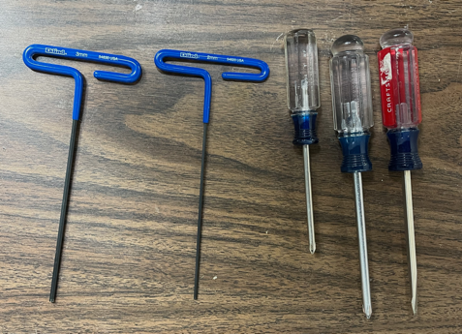
- Patience

INTRODUCTION
freETarget is an open source project to provide shooters with a low cost electronic target. To simplify the construction, the FreeETarget Flatpack was created to provide a single location for the mechanical construction.
The latest CAD files can be found at Github.com/ten-point-nine/freeetarget in the mechanical/cnc folder.
These instructions are for assemblies made after November 2022. Prior to that the screw assembly was not available and needed to be assembled with glue.
Assembling the flatpack is in five parts
- Assembling the back panel
- Assembling the frame
- Assembling the door
- Assembling the target plate
- Target assembly

PACKING SLIP
Item | Description | Quantity
 | Frame
1 | Top | 1
2 | Left with hinges installed | 1
3 | Right with magnets installed | 1
4 | Bottom | 1
5 | Back with sensor mounts and face plate bolts installed | 1
6 | Door | 1
7 | LED mounts | 4
8 | Witness paper mounts | 2
 | Assembled Parts
9 | Witness paper drive with (qty) 4mm x 12 bolts | 1
10 | Multifunction switches | 1
11 | WiFi cable | 1
 | Target Face
12 | Optional pistol face plate | 1
13 | Optional pistol target holder | 1
14 | Optional rifle face plate | 1
15 | Optional rifle target holder | 1
16 | 5mm mounting screws | 8
17 | Witness paper guide | 1
 | Piece Parts
18 | Side mounting bolts 4mm x 22 or 25 | 8
19 | Back mounting bolts 4mm x 18 or 20 | 10
20 | Nuts 4mm | 18
21 | Arduino mounting bolts 3mm x 25 | 4
22 | Sensor mounting bolts 3mm x 18 | 8
23 | Door mounting bolts 8mm | 4
24 | Nuts 3 mm | 16
25 | WiFi mounting screws #2x1/4” | 4
26 | Wire ties | 10
27 | Witness paper dowel | 1

Assembling the Back Panel
1 | Back Panel with Sensor Mounts | 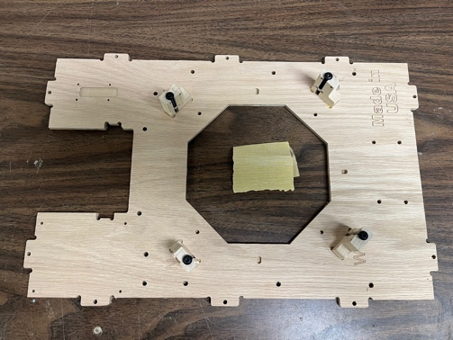
2 | Install the witness paper mounts, 2x | 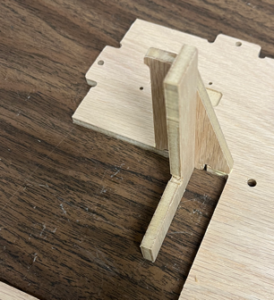
3 | Install the cable guides to the back panel  There are six guides that glue into the six slots on the back panel. They server to hold the flat cable in place and prevent the cable from falling into the pellet area.  IMPOTANT  Do not install the rightmost pair if you intend to use the face strike detector. | 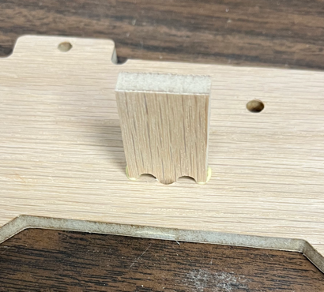
4 | Install the WiFI base to the back using the small wood screws.  If you have trouble holding the screws while installing, try taping the screw to the screwdriver. | 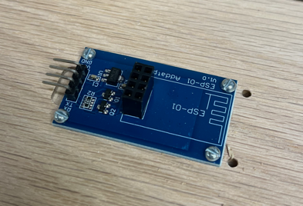
5 | Install the four sensors to the sensor mounts.  Make sure that the sensors (ex North) match the mount (ex N) | 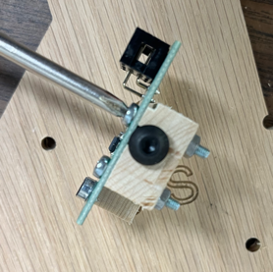
6 |  | Installing the light harness.  These instructions will change depending on the light harness you use. This illustration is based on a light harness that has a removable dimmer switch
7 | 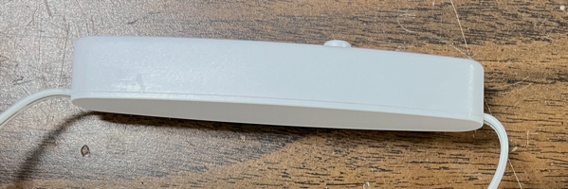 | Cut the dimmer switch out and strip the insulation from all of the ends
8 | 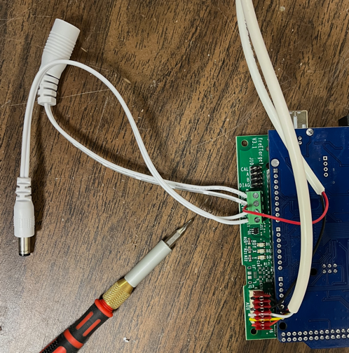 | Install the connectors as shown in the photo  WiFi wiring harness to AUX connector  12V LED ground to the GND terminal  12V LED + supply to the +12 terminal  Motor RED conductor to the +12 termainl  Positive LED lead to the LED+  Negative LED lead to the LED-
9 | Install the witness paper drive using the 4mmx12 screws. | 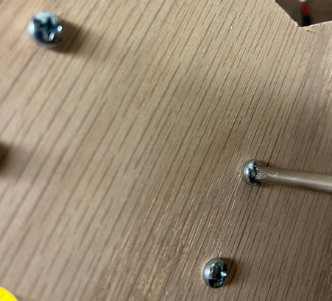
A | Install the Arduino 3mmx25 mounting screws.  Hold in place with nuts.  Do not tighten completely | 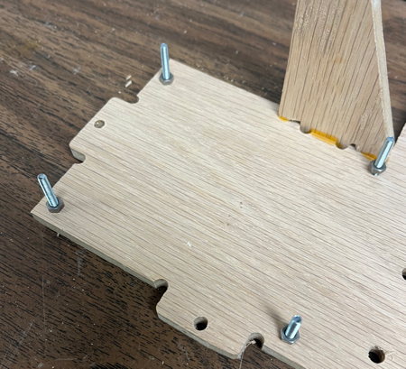
B | 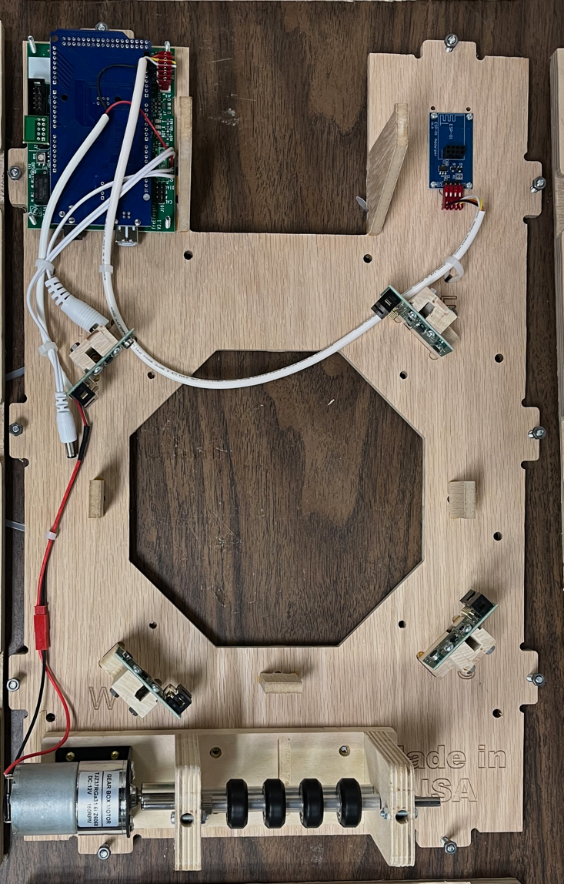 | Finish installing the hardware  Mount Arduino to mounting screws  Attach WiFi cable. Note black wire to the left  Attach motor connector  Install the USB Cable (not shown) to the Arduino  Install the ESP01 WiFi component (not shown) at this time

Assembling the Frame
1 | Locate and identify the four frame parts,  Top  Bottom  Left  Right | 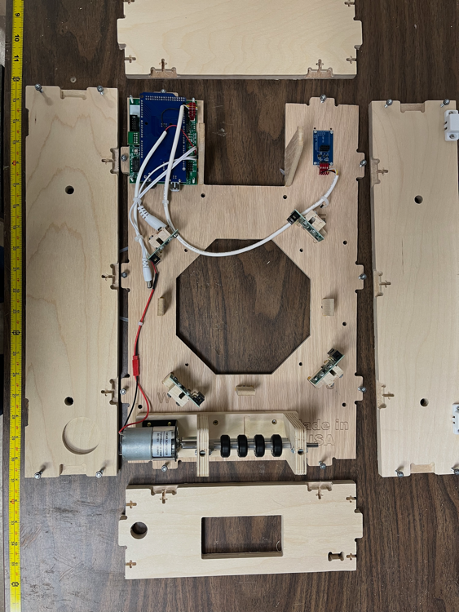
2 | 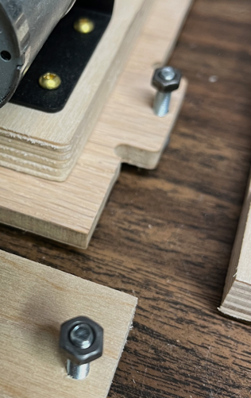 | Through the back, insert the 4mm x 18 (or 20 mm) screws from the back to the front. Hold in place by inserting the nuts to the top of the bolt.  Through the side, insert the 4mm x 22 (or 25) screws from the side to the inside of the side panels. Hold in place by inserting the nuts to the top of the bolt.
3 | 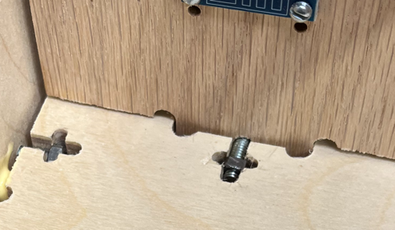 | Carefully push the side panels onto the back using the screws and nuts to hold in place.  When all three bolts for one panel are in place, snug down but do not tighten.  You may need to use a screwdriver of knife to push the nuts all the way in place to get a good fitting.
4 | Repeat the process for attaching the top and bottom panels.  You may want to add some glue before tightening up the frame. | 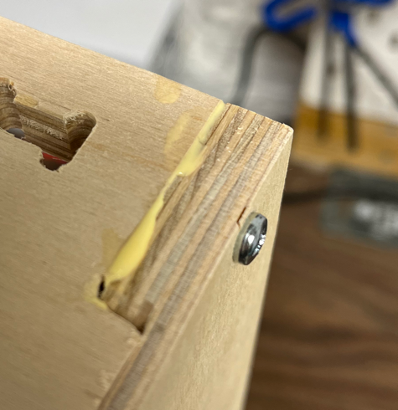
5 | Start tightening up all of the screws.  Make sure that the frame is lined up before the final turn.
6 | Glue the switches to the bottom | 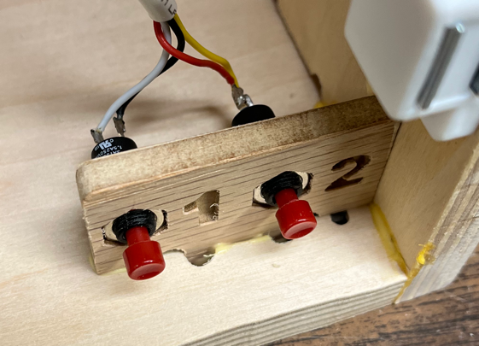
7 | 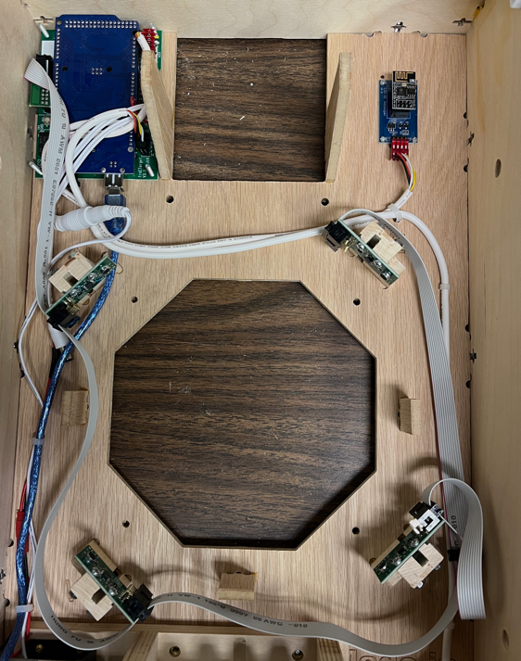 | Install the flat cable from the Arduino to all of the sensors.  Start from the Arduino and work  North  West  South  (skip)  Face  Align the other cables as show in the picture
8 | 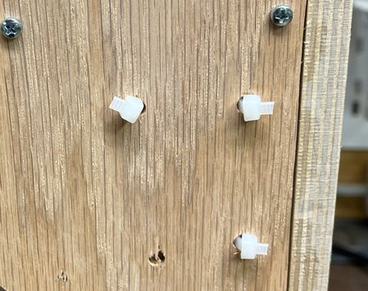 | Route all of the cables on the inside and hold in place by looping a zip-tie from the back, around the cable, and back out again.  Tie in place and cut off excess zip tie.

Assembling the Face Plate
1 | Install the paper guide using the ½” wood screws.  Note the orientation of the two mounting screws on the right of the paper | 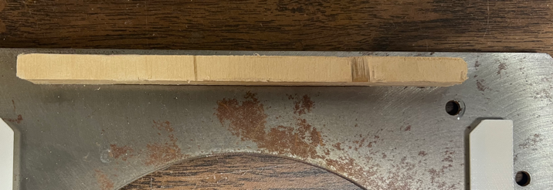
2 | Using the 3mm x 5 screws, attach the target paper guide onto the face plate.  Insert the screws, but do not tighten completely.  Tighten starting from the bottom two screws and work bottom to top.  Snug the screws, but do not overtighten. The target paper guide is made from 3D printed plastic and will strip the screws if overtightened. | 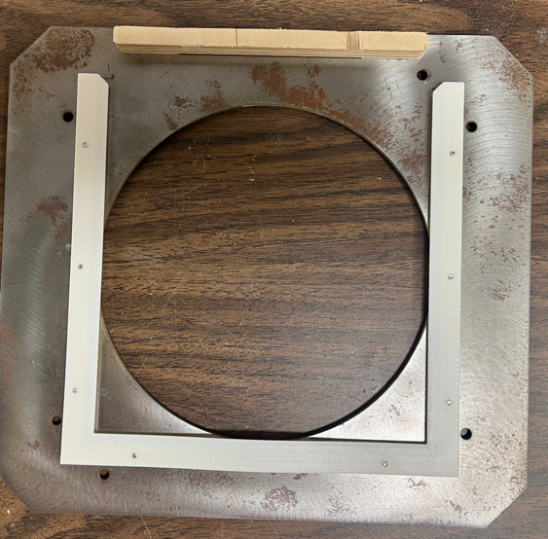
3 | If using the face strike detector,  Using the face plate spacer, install the face sensor using 3mm 18 screws | 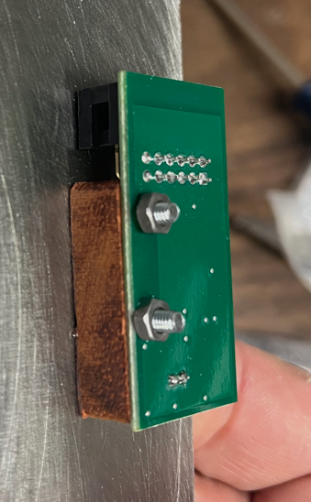
4 | Attach the face sensor to the flat cable harness | 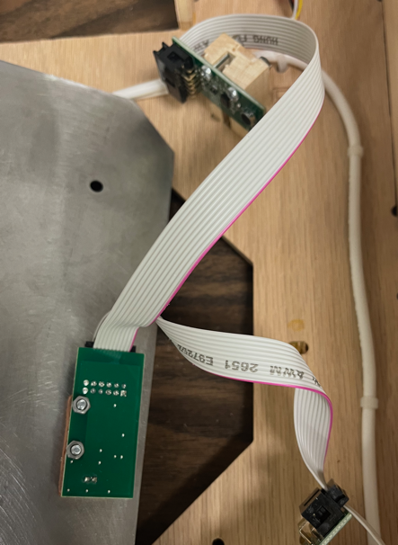
5 | 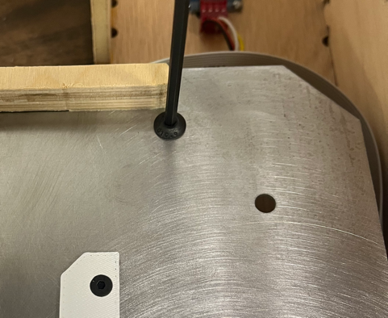 | Flip the face plate onto the base and attach with the long 5mm screws.  Do not overtighten

Installing the Door
1 | Glue the LED mounts in place (4x) | 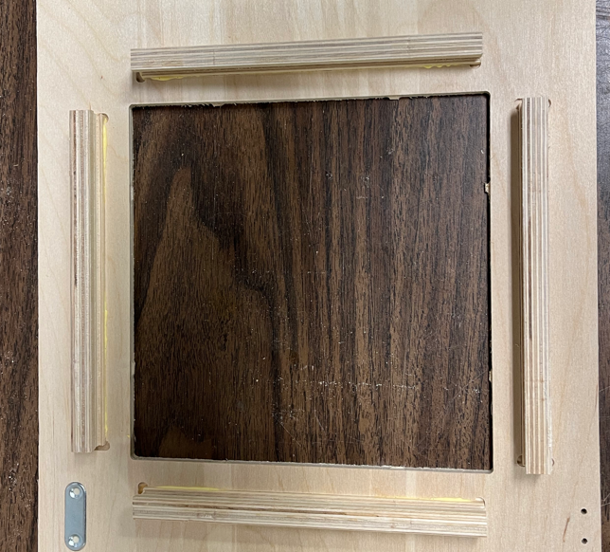
2 | Attach the door to the hinges using the countersunk 3mm screws | 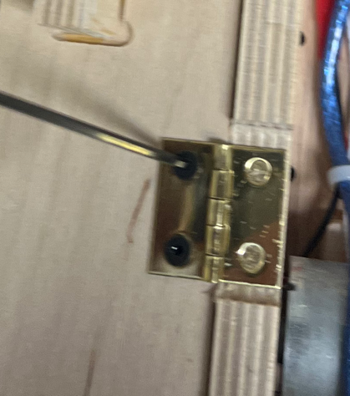
3 | Install the LED light strip  Remove the release paper and tape to the LED mounts.  From the open position,  Start Bottom Right  Wind in counter clockwise direction | 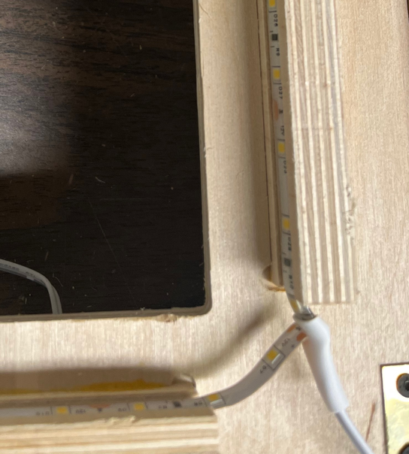
4 | Connect the 12V power supply and LEDs to using the barrel connectors supplied

DOWNLOADING AND INSTALLING PC SOFTWARE
Click the link below to go to the downloads page
https://free-e-target.com/downloads/
Look for the PC Software section and download the software (Figure 9)
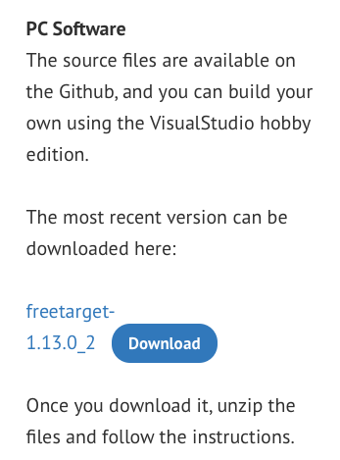
Figure 9: Download Software

Unzip the software and install on your PC.
Connect the USB cable between the target holder and the PC.
STARTING UP
Launch the PC program and look for the setup icon (GEAR WHEEL) in the upper right corner (See Figure 10)
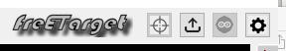
Figure 10: Setup Icon Location

Enter all of the setup information needed in Figures 9, 10, 11, and 12
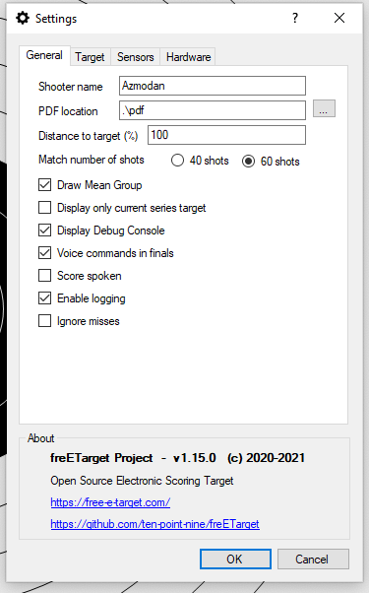 | 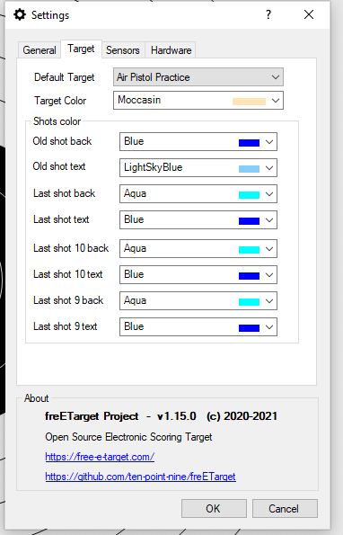 | 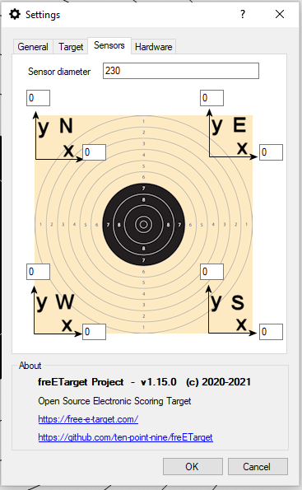 | 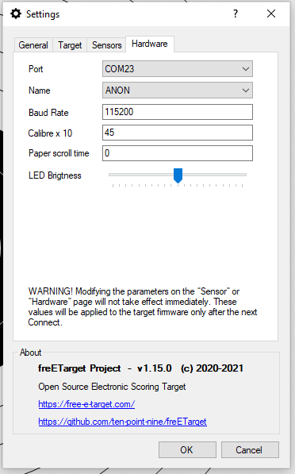
Figure 11: General Settings | Figure 12: Target Settings | Figure 13: Sensor Adjustment | Figure 14: Hardware Interface

Figure 11: This allows you to enter the shooter name and how information will be stored.
Figure 12: Choose the target you will be shooting against and the colours you will be using.
Figure 13: Fine tune the sensor position to adjust for assembly errors
Figure 14: Interface to the target hardware.

Press 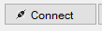 to begin a session.

Refer to the Commissioning Instructions from the web site. This will give you a quick summary of how the system is working
TROUBLESHOOTING
The boards are tested before shipment, but a lot can happen between the last test and the first shot. If your system is not working, please follow the trouble shooing guide below before sending an email to freETarget.com
PC Program complains “Database Check Fails..: | - Security issue with some antivirus software  - Try running as administrator  - Disabling antivirus
PC Program cannot see target | - The Arduino uses a CH340 which may not have a driver on your PC  - Follow the instructions at https://sparks.gogo.co.nz/ch340.html to load in the correct driver
No Shots Registered | - Check that the USB cable is attached  - Check that the correct Serial port is set in the setup  - Check that the wiring harness is attached to all of the sensors  - Tap each of the sensors. Do the three LEDs blink?
Shots show up but in the wrong place | - From the firing line, shoot a blank shot  - Do the three LEDs blink?  - Yes, set a new trip point  - No, Check all of the wiring  - Verify that the sensors North – West are in the correct order
The shots show up but rotated 90 degrees | - Verify the order of the sensors and correct
The shots are the mirror image left-right | - The sensors are reversed. Switch the positions of NORTH-EAST and SOUTH-WEST

APPENDIX A – freETarget Components
